## Question Summary

**Within Java, a button component can be used for triggering different events. There are different types of buttons that can be utilised. Flemings Electrical Ltd based in the Republic of Ireland trade with the UK. On 1st January 2021, because of Brexit, extra details are required on their VAT return to handle Postponed VAT Accounting (PVA). They have hired you to develop an application which will allow a user to type in this extra information. The information that is required is as follows:**

* **Year – integer value – greater than 2020 and less than 2050.**
* **Month – integer value – range 1 to 12.**
* **VAT Reference – string – minimum characters 10.**
* **Goods amount – float – should allow negative values.**

**Because Flemings Electrical do not trade with the UK every month, not all months require this information to be entered. You are required to:**

**a) Write a class to represent the PVA information required. You should ensure that the setter methods for your properties performs the required validation.**

Class pvaInfo contains all data members outlined in the question about.

**private** **int** year;

**private** **int** month;

**private** String VATref;

**private** **double** goodsAmount;

These data variables are retrieved and returned by using getters and setters.

The validations for the year done using if statement that pops up an error message if out of range. I had a text field here initially but changed this to a JComboBox for a drop-down list which avoided need for the validation. The same process was repeated for the month.

**public** **void** setYear( **int** Year)

{

**if** (Year >= 2020 && Year<= 2050)

{

**this**.year = Year;

}

**else**

{

JOptionPane.*showMessageDialog*(**null**, "Please Select a year between 2020 - 2050", "Invalid Data", JOptionPane.***ERROR_MESSAGE***);

}

}

**b) The requirements for this PVA input screen are as follows:**

1. **The user is allowed enter in the Year / Month.**
2. **The user can then choose whether this Year/Month combination requires VAT information to be input. Utilise one of the GUI components to enable / disable the VAT Reference / Goods fields entry. These fields should only be enabled if the user has indicated that they have data for this month. Note – if there is no data to be entered, then only the year and month are saved to your class.**
3. **A Cancel button is required on this input screen. If the user clicks this button, they should be asked to confirm they want to exit. Exit should close the PVA input screen.**
4. **A Save button is required which allows you to save the data that the user entered. This button should only be enabled when the user has entered in valid data. When the Save button is clicked – the user should be asked to confirm that the data is correct. The data should be saved to a text file – no specific format required.**

**You are required to:**

1. **Provide a flowchart or pseudocode to represent the requirements.**

**Pseudocode**

**pvaInfo class**

declare variables

Year

Month

VATno

GoodsAmount

declare constructor pvaInfo with variables

set year

if within range set

else

error popup

get year

return year

set month

if within range set

else

error popup

get month

return month

set VAT

max 10 char

else

error popup

get VAT

return VAT

set goods amount

get goods amount

return VAT

**GUI Class**

declare Jobjects

frame

panel

buttons

labels

textfields

combo box

declare variables to pass from GUI to pvainfo

constructor pvaInfo

GUI method()

Set arrays for combobox

Frame

Panel

Year label, comboBox

month label, comboBox

vat label, text field

goods amount label, text field

enable checkbox label

cancel button

setactioncommand cancel

save button

if ticked

setactioncommand VAT

if not ticked

setactioncommand exVAT

Actionperformed method()

actioncommand cancel

popup confirm

close or do nothing

actioncommand save VAT

SaveInfo()

Printfile()

popup confirming

actioncommand save exVAT

SaveInfoExtVat()

Printfile()

popup confirming

SaveInfo() method

Gets input info from GUI sets in pvaInfo

All datamembers

SaveInfoExtVat() method

Gets input info from GUI sets in pvaInfo

Set VAT and Goods to N/A and 0

All datamembers

Printfile() method

Trys

Print all data from pvaInfo to file

Catch errors

Main ()

Calls GUI

1. **Write a GUI to satisfy these requirements.**

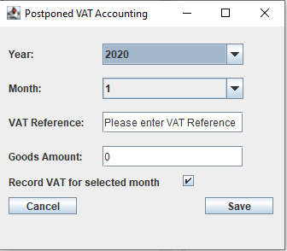

GUI was designed to be clean and easy to use. Everything is clearly labeled an optimized to avoid confusion.

Year and month selection allows the user to pick between the specified range. VAT reference is input via a text field along with the goods amount.

For the months where VAT information is not needed the check box can be unticked. This will print out an alternative version where the VAT information is not present.

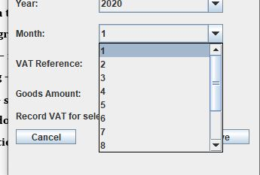

Clicking the save button a prompt will pop up advising the file has been saved.

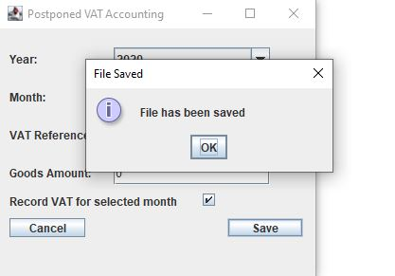

When the user hits the cancel button a prompt to confirm will pop up. If yes is selected it will terminate the program. If no it will revert back to the program.

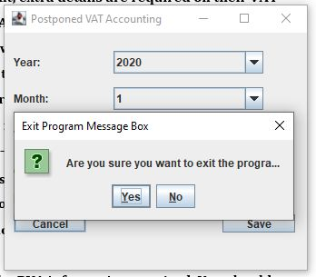

1. **Provide a test plan indicating several tests which will test the requirements.**

For Testing I designed three tests case to access the functionality of the program

1. Test for negative entries – ensure the system can accept negative entries as is outline in the question.
2. Test writing to file/creating file – ensure the system saves all required information to a file when the save button is pressed.
3. Test exit prompt on cancel button – ensure the system prompts the user to confirm closing the program once the cancel button has been pressed.
4. Test not ticked and save button pressed - If not ticked and save button pressed VAT information should not print into file.
5. **Provide an execution plan (screen shots) based on your test plan proving that the requirements have been fulfilled.**

Test Cases have been attached in Appendix 3.